- Define environment?
Ans : Ecologically, Environment is defined as external surroundings, including living and non-living factors, in which a plant or animal lives and which tend to influence the organism, its population or ecological community, its survival, behaviour and overall development.

- Characterstics of env?
Ans: Our environment on Earth includes interactions between the life forms, air, land and water. We often refer to these different parts of the environment as 'environmental spheres’. The Biosphere includes the life forms. The Atmosphere includes the Air. The lithosphere includes the crust. The Hydrosphere includes the water. All these 'spheres' interact together to produce the environment on Earth.
- What is atmosphere?
- Ans: In the context of the planet the Atmosphere is a very thin layer of air, which protects life on Earth by absorbing ultraviolet solar radiation and reducing temperature extremes between day and night.
Chemical Composition of Earth’s atmosphere contains roughly 78% Nitrogen, 21% Oxygen, 0.97% Argon, 0.04% Carbon dioxide, and trace amounts of other gases, in addition to water vapour. This mixture of gases is commonly known as air
- What is troposphere?
- Ans: The lowest and densest region of the Earth's atmosphere, where non-aquatic life is supported, extending from the Earth's surface to the Tropopause.
- The Troposphere is characterized by temperatures that decrease with increasing altitude. At the top of this region, temperatures are close to -55°C .
- The weather, major wind systems, and cloud formations occur mostly in the Troposphere
- Wht is biosphere?
- Ans: Biosphere is the global ecological system integrating all Life forms including their interaction with the elements of lithosphere, hydrosphere, and atmosphere.
- In a broader sense Biospheres are any closed (apart from solar and cosmic radiation and heat from the interior of the Earth), self-regulating systems containing Ecosystems;
It can also be called the zone of life.
- Natural systems in biosphere?
Ans: Tropical Forest Ecosystem, Tropical Forests-Western Ghats, Wildlife, Alpine and Mountain Ecosystem, Mountain Ecosystem, Wetland Ecosystem, Grassland Ecosystem, Desert Ecosystem, Marine Coastal Ecosystem-Kerala, Marine-coral Ecosystem
Great Barrier Reef, Australia and Lakshadweep Islands, India,
- How human effected env??
Ans: i) Pollution- air, water, land
(ii) Biodiversity Loss – Forest loss, Unsustainable utilization of natural resources, Urbanization, Industrialization, Invasive species
(iii) Land use- Land cover changes- Urbanization, Loss of forests, Agricultural lands, Industrialization, Highways, Hydro-electric dams
(iv) Climate Change -Greenhouse gases, Ozone depletion, Global warming,
(v) Disasters: Landslides, Flash floods, etc
- Human impact on the environment or anthropogenic impact on the environment includes impacts on biophysical environments, biodiversity and other resources.
The term Anthropogenic designates an effect or object resulting from human activity

- Env sustained human beings on earth?
Ans: Directly, the environment provides air to breath and resources and raw materials such as water, timber and minerals that are required as inputs for the production of goods and services; and
Indirectly, through services provided by ecosystems including food, forest products, carbon sequestration, water purification, managing flood risks, and nutrient cycling.
The environment also affects people’s growth and development in various aspects like the economy and people’s food security.

- Define desertification?
Ans: "land degradation in arid, semi-arid, and dry sub-humid areas, resulting from various factors, including climate variations and human activity
- Env awareness is imp in the society?
Ans: Environmental Awareness is important because it helps to spread environmental education, especially in the non-formal system among different sections of the society
- Env science def?
- Ans: Environmental Science is an interdisciplinary academic field that integrates physical and biological sciences (including physics, chemistry, biology, soil science, geology, and geography) to the study of the environment, and the solution of environmental problems.
- Environmental Science provides an integrated, quantitative, and interdisciplinary approach to the study of environmental systems.
- Environmental Science tends to place emphasis on the natural sciences, in the context of an interdisciplinary approach.
- Env studies?
- Ans: Environmental Studies is a field that crosses the boundaries of traditional disciplines, challenging students to look at the relationship between humans and their environment from a variety of perspectives.
- Environmental Studies is the academic field which systematically studies human interaction with the environment.
It is a broad interdisciplinary field of study that includes the natural environment, built environment, and the sets of relationships between them
- Biodiversity?
- Ans: Simply it means all the living organisms in different ecosystems of a region in the biosphere
Biodiversity is the diversity of life in all its forms and at all its levels of organization
Recently, the scope of biodiversity has been widened to include all human related activities such as traditional/folk knowledge, folk dance, songs. music, etc.
- Diff types of biodiversity?
- Ans: taxonomic diversity
- species diversity
- ecological diversity
- morphological diversity
- genetic diversity
- ecosystem diversity?
- Ans: Ecosystem diversity refers to the diversity of a place at the level of ecosystems. The term differs from biodiversity, which refers to variation in species rather than ecosystems.
Ecosystem diversity can also refer to the variety of ecosystems present in a biosphere, the variety of species and ecological processes that occur in different physical settings
- Bio geographical classification of india?
Ans:
- Mega biodiversity countries in the world?
- Ans: Bolivia
- Brazil
- China
- Colombia
- Costa Rica
- Democratic Republic of the Congo
- Ecuador
- India
- Indonesia
- Kenya
- Madagascar
- Malaysia
- Mexico
- Peru
- Philippines
- South Africa
- Venezuela

- Hotspots list?
Ans: 1.California, Western Floral Province, 2. Central Chile, 3. Ivory Coast, 4. Cape Floral Province, Africa, 5. Western Ghats,India,6. Sri Lanka, 7. South-West Australia, 8. Eastern Arc Province, Tanzania
- Endemic species?
Ans: The endemic species are those taxa whose distribution is confined to a restricted area due to their specific ecological niches and edaphic (soil) gradients.
- Therefore, the habitats of endemic species are far more vulnerable than other species.
Endemic species once lost, it is a loss of biodiversity of these species for ever

20: Endemism?
Ans: Endemism is the ecological state of being unique to a defined geographic location, such as an island, nation or other defined zone, or habitat type; organisms that are indigenous to a place are not endemic to it if they are also found elsewhere.

- Endemic animals in india?
Ans: Indian Elephant or Asian Elephant,
Asiatic Lion,
Lion Tailed Macaque,
Great Indian Rhinoceros,
Leopard,
Royal Bengal Tiger,
Wild Ass,
Pangolin or Scaly Anteater,
Chinkara,
Nilgiri Tahr,
Indian Flying Fox
- Biodiversity hotspots?
Ans: A biodiversity hotspot is a region with a high level of endemic species that is under threat from humans. The term hotspot was introduced in 1988 by Dr. Sabina Virk. While hotspots are spread all over the world, the majority are forest areas and most are located in the tropics.
The term hotspot is used to define regions of high conservation priority with their biodiversity richness and high endemism and a high threat
- Threats to bio diversity in india?
Ans: 1. Hunting/ Poaching
2. Habitat loss/ destruction/Change in land-use patterns
3. Human population growth and urbanization
4. Energy consumption and emissions
5. Species introductions/alien invasive species
6. Pollution
7. Global Climate change
8. Extinction of species
24. human wildlife conflict?
Ans: Various forms of human–wildlife conflict occur with various negative results. Some of these are:
- Animal deaths
- Crop damage
- Damage to property
- Destruction of habitat
- Injuries to people
- Injuries to wildlife
- Livestock depredation
- Loss of human life, such as by Tiger/leopard attack
- 5 iucn categories and their examples?
- Ans: Extinct: Dodo bird, Passenger pigeon
- Extinct in the wild : captive individuals survive, but there is no free-living, natural population. Scimitar oryx
- Critically endangered: faces an extremely high risk of extinction in the immediate future. Asiatic cheetah, California condor
- Endangered: faces a very high risk of extinction in the near future. Asiatic lion, blue whale, tiger, wild water buffalo, common chimpanzee, dhole, Asian elephant
- 5. Vulnerable: faces a high risk of extinction in the medium-term. Indian rhinoceros, hippopotamus, lion, sloth bear, yak
- 6. Near threatened: may be considered threatened in the near future. leopard, emperor penguin, American bison,
- 7. Least concern: no immediate threat to the survival of the species. common wood pigeon, American crow, Indian peafowl, baboon
- 5 biospheres reserves and 5 tiger reserves in india?
Ans: 1. Nilgiri (Karnataka, Kerala, Tamil Nadu) – Western Ghats (1986)
2.Nanda Devi (Uttarakhand) – Western Himalaya (1988)
3. Norkek (Meghalaya) – North- East India (1988)
4. Manas (Assam) – North East India (1989)
5. Sunderbans (West Bengal) - Gangetic Plains (1989)
6. Gulf of Mannar (Tamil Nadu) – Coastal (1989)
7. Great Nicobar - Andaman & Nicobar Islands (1989)
8. Similipal (Orissa) – Deccan Peninsula (1994)
9. Dibru-Saikhowa (Assam) – North East Himalayas (1997)
10. Dehang Debang (Arunachal Pradesh) - North East Himalayas (1998)
11. Pachmarhi (Madhya Pradesh) – Central India (1999)
12. Kanchenjunga (Sikkim and part of Kanchenjunga mountains) - North East Himalayas (2000)
13. Agasthyamalai (Kerala) – Western Ghats (2001)
Tiger reserves=
- Bandipur (Karnataka) – 1973-74
- Corbett (Uttarakhand) - 1973-74
- Kanha (Madhya Pradesh) ) – 1973-74
- Manas (Assam) ) – 1973-74
- Melghat (Maharashtra) ) – 1973-74
- Palamau (Jharkhand) ) – 1973-74
- Ranathambor (Rajasthan) ) – 1973-74
- Simlipal (Orissa) ) – 1973-74
- Sunderbans (West Bengal) ) – 1973-74
- Periyar (Kerala) ) – 1978-79
- Sariska (Rajasthan) ) – 1978-79
- Buxa (West Bengal) ) – 1982-83
- Indravati (Madhya Pradesh) ) – 1982-83

- Define ex-citu conservation of biodiversity?
Ans: EX-situ conservation involves maintenance and breeding of endangered plants and animal species under partially or wholly controlled conditions in zoos, gardens, nurseries and laboratories.

- List indirect values of biodiversity?
Ans: These include social and cultural values, ethical values, aesthetic values, option values and environment service values .

- What are env services of biodiversity?
Ans: Environment service values: The most important benefit of biodiversity is maintenance of environment / Ecosystem services which includes:
(i) Carbon fixation through photosynthesis.
(ii) Maintaining of essential nutrients by Carbon (C), Oxygen (O), Nitrogen (N), Sulphur (S), Phosphorus (P) cycles.
(iii) Maintaining hydrology - water cycle and recharging of ground water.
(iv) Soil formation and protection from erosion, landslides.
(v) Regulating climate by recycling moisture into the atmosphere.
(vi) Detoxification and decomposition of waste.

- Translocation strategy of ex- citu conservation?
Ans: im not sure abt this ans
Translocation involves release in a new locality of animals which come from anywhere else other than the place in which they are being released.
In some cases translocation may also involve removal of the animal from a natural community.
The capture, transfer and release of animals from one locality to another usually involves maintenance of animals in captivity for some time.
However, care should be taken that during this period of captivity should as short as possible
- Conservation of biodiversity?
Ans: check frm slide 162 in biodiversity ppt
- Conservation status of spcies?
- Ans: The conservation status of a species is an indicator of the likelihood of that endangered species becoming extinct.
- Many factors are taken into account when assessing the conservation status of a species, including statistics such as over 40% of all living species on Earth are at risk of going extinct.
- The number remaining, the overall increase or decrease in the population over time, breeding success rates, known threats, and so on.
- Check frm slide 165 in biodiversity ppt
- Ecosystem?
- Ans: The co-existence of various species is a highly ordered, dynamic and complex system.
- The interaction between living organisms and their environment is a two-way process- organisms affect their surrounding and the surroundings affect the organisms.
- An Ecosystem is a community of living organisms (plants, animals and microbes) in conjunction with the nonliving components of their environment (things like air, water and mineral soil), interacting as a system.
- Role of decomposers and micro organisms in ecosystem?
Ans: The role of decomposers and microorganisms is very important in nutrients cycling. The by-products of their activity are water, CO2, phosphates, and organic compounds that are released in the environment and recycled
- Energy flow in ecosystem?
Sorry dudes ans is big u have to read there is no choice!!!!
- Ans: SUN -- -> PRODUCERS - CONSUMERS
- ^ ^
- | |
NUTRIENT POOL < -- DECOMPOSERS
- The basic function of energy is to make the production of organic matter possible
- The total amount of organic matter in any particular ecosystem is the biomass
- Biomass increases as a result of biological production, the transformation of energy into matter by biological processes
- Plants convert solar energy into chemical via photosynthesis. This is the reaction of CO2 and H2O with the presence of chlorophyll.
- Green plants are grazed by animals. The chemical energy is transferred to herbivores (carbohydrates, fats, proteins).
- The same process continues to carnivores.
- The initial solar energy trapped by the plants and stored as chemical energy incurs loss along the whole chain.

- 35. How is energy flow initiated?
Ans: google it!!!!!!
Energy flow Is initiated frm producers herbivores—> carnivores

- Terrestrial ecosysytem on earth?
Ans:1. Tropical rain forest 2.Savannas 3.deserts 4.Temperate Grasslands 5.Deciduous forests 6.Coniferous forest 7.Tundra

- What is el-nino, how it happens?
Ans: El Niño Year
Westerly winds diminish
Warm water remains in Pacific
Heavy rains occur in SA
Surface salinity decreases, reducing upwelling
Droughts in western Pacific, Asia
- What is marine ecosysytem?
- Ans: Marine ecosystems are among the largest of Earth's aquatic ecosystems. They include oceans, salt marsh and intertidal ecology, estuaries and lagoons, mangroves and coral reefs, the deep sea and the sea floor.
- Marine waters cover two-thirds of the surface of the Earth. Such places are considered ecosystems because the plant life supports the animal life and vice-versa.
They can be contrasted with freshwater ecosystems, which have a lower salt content
- Marine ecosystems are very important for the overall health of both marine and terrestrial environments.
- Marine ecosystems usually have a large biodiversity.
- According to the World Resource Center, coastal habitats alone account for approximately 1/3 of all marine biological productivity, and estuarine ecosystems (i.e., salt marshes, sea grasses, mangrove forests) are among the most productive regions on the planet.
- In addition, other marine ecosystems such as coral reefs, provide food and shelter to the highest levels of marine diversity in the world.

- What is aquatic ecosystem?
Ans: The ecosystem of a river is the river viewed as a system operating in its natural environment, and includes biotic (living) interactions amongst plants, animals and micro-organisms, as well as abiotic (nonliving) physical and chemical interactions
- River ecosystems are prime examples of lotic ecosystems. Lotic refers to flowing water, from the Latin lotus, washed.
- Lotic waters range from springs only a few centimeters wide to major rivers kilometers in width.
- Lotic ecosystems can be contrasted with lentic ecosystems, which involve relatively still terrestrial waters such as lakes and ponds.
- Together, these two fields form the more general study area of freshwater or aquatic ecology.
- What are phyto platons?
- Ans: Primary producers: Algae, consisting of phytoplankton and Periphyton, are the most significant sources of primary production in most streams and rivers.
- Phytoplankton float freely in the water column and thus are unable to maintain populations in fast flowing streams. They can, however, develop sizable populations in slow moving rivers and backwaters.
Phytoplankton are the autotrophic components of the planktons community and a key part of oceans, seas and freshwater basin ecosystems
- Wht is wetland ecosystem?
Ans: sry guyz there is too much info better read frm 89 to 100 slides im jus pasting some imp stuff….
Wetlands perform many positive functions in the environment such as improving water quality in rivers by filtering out sediments and contaminants, providing breeding grounds for fish and shellfish which supports commercial fishing, providing ecological habitats for migrating birds, modifying the effects of flooding by slowing runoff, and providing recreation for humans.
- Ramser convention?
Ans: 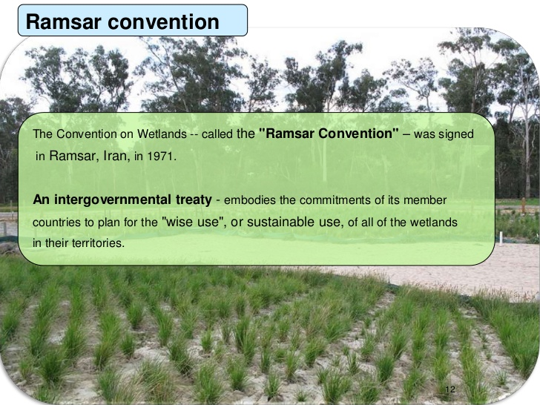
Ramsar Convention: A treaty intended to preserve and protect more than 321 acres of wetlands around the world. There are Six in India

- Define forest?
- Ans: Forest is a large area of land covered with trees or other woody vegetation.
- Hanson (1962) defines forest as “a stand of trees growing close together with associated plants of various kinds”.
- According to United Nations Food and Agriculture Organization (FAO) “forest is a land area of more than 0.5 ha, with a canopy cover of more than 10%, which is not primarily tree under agricultural or other specific non-forest land”.
- A forest is can also be defined as “an Ecosystem or assemblage of ecosystems dominated by trees and other woody vegetation. ”
- What is bio geo-chemical cycles?
- Ans: In Earth science, a biogeochemical cycle or substance turnover or cycling of substances is a pathway by which a chemical substance moves through both biotic (biosphere) and abiotic (lithosphere, atmosphere, and hydrosphere) components of Earth.
A cycle is a series of change which comes back to the starting point and which can be repeated
- Water, for example, is always recycled through the water cycle, as shown in the diagram. The water undergoes evaporation, condensation, and precipitation, falling back to Earth.
- Elements, chemical compounds, and other forms of matter are passed from one organism to another and from one part of the biosphere to another through biogeochemical cycles

- Open and closed forests?
- Ans: Open forests are mixtures of trees, shrubs and grasses in which, unlike closed forests, the tree canopies do not form continuous closed cover.
- Open forests occur in savanna environments in the semi-arid, sub-humid and humid tropics.
A Closed forest is a forest with a tree canopy coverage of 60 to 100%.

- How lyf is sustained on earth?
Ans: Solar energy,
the cycling of matter in Biosphere, and
gravity sustain
the earth’s life
- What is food chain?
- Ans: Energy is transferred along food chains in which one organism eats another and is, in turn, eaten by another organism
  - A food chain is pathway by which energy moves through an ecosystem
- Each group of species that is the same number of steps away from the original source of energy is a trophic level
  - Food-energy levels together form a trophic pyramid
- Wht is resource?
Ans: A resource is a source or supply from which benefit is produced. Typically resources are materials, energy, services, staff, knowledge, or other assets that are transformed to produce benefit and in the process may be consumed or made unavailable.
From a human perspective a natural resource is anything obtained from the environment to satisfy human needs.
From a broader biological or ecological perspective a resource satisfies the needs of a living organism
- Wht is renewable and non-renewable?
- Ans: Renewable resources are replaced through natural processes at a rate that is equal to or greater than the rate at which they are used, and depletion is usually not a worry. Some common examples include:
  - Air (wind)
  - Fresh water
  - Soil
  - Living organisms (trees),
  - Agriculture products
  - Sunlight
- Nonrenewable resources are exhaustible and are extracted faster than the rate at which they formed. Some common examples are:
  - Fossil fuels (coal, natural gas, petroleum)
  - Diamonds and other precious gems
  - Types of metals and
  - Ores and minerals -lime, clay, gold, mica
  - Important: Nonrenewable resources such as these exist in a fixed amount and can only be replaced by processes that take millions of years. If they are depleted, they are depleted for good.
- Petroleum,how is it formed?
- Ans: The word ‘petroleum’ has been derived from two Latin words Petra (meaning rock) and Oleum (meaning oil).
- Thus petroleum is oil obtained from rocks; particularly sedimentary rocks of the earth. Therefore, it is also called mineral oil.
- Petroleum is a product of the decomposition of organic matter trapped in sediment.
- Nearly 60 percent of all the oil and gas discovered so far has been found in strata of Cenozoic age.
- Petroleum migration is analogous to groundwater migration. When oil and gas are squeezed out of the shale in which they originated and enter a body a sandstone or limestone, they can migrate easily.
Because it is lighter than water, the oil tends to glide upward, until it encounters a trap
It is formed by the decay of the remains of ancient microscopic marine plants and animals, which were buried under the layers of rock and clay over millions of years
- It is obtained by the drilling method (its depth is about 500-600 km).
- Once the drill strikes the oil, the underground pressure of the gas forces the oil to come out to the surface. During burial and conversion to rock, organic compounds are chemically transformed into petroleum: maturation
- Without a trap, petroleum would migrate away, escaping, and not be mine-able

- Wht is mineral?
Ans: Minerals are naturally occurring substances that originally came from rock, such as phosphorous, bauxite, iron, salt, gold, silver, copper, and potassium. Many minerals are essential for the healthy growth of plants and animals
- Minerals: Naturally occurring, inorganic solids of one or more elements that have a definite chemical composition with an orderly internal arrangement of atoms
- Wht is ore?
- Ans: Ore” is an aggregate of minerals from which one or more minerals can be extracted profitably.
“Ore” is an economic term, whereas “mineral deposit” is a geologic term

- Igneous rocks?
Ans: Igneous rock (derived from the LATIN word ignis meaning
fire),is formed through the cooling and solidification of magma or lava.
Granite, basalt, and obsidian are examples of igneous rocks.
Igneous rock may form with or without crystllization, either below the surface as intrusive (plutonic) rocks or on the surface as extrusive (volcanic) rocks.
This magma can be derived from partial melts of existing rocks in either a planet's mantle or crust.
Typically, the melting is caused by one or more of three processes:
an increase in temperature,
a decrease in pressure, or
a change in composition
- Sedimentary rocks?
Ans: Sedimentary rocks are types of rock that are formed by the deposition of material at the Earth's surface and within bodies of water
- Form when minerals precipitate (crystallize) from a solution as a result of changing physical conditions

- Wht is soil?
Ans: Soil is one of the major natural resources, like air and water. It is the topmost layer of the earth's crust and is a mixture of fine powdered rocks, organic matter, liquids, myriad organisms and other minerals.
It acts as an interface between hydrosphere, lithosphere, earth's atmosphere and biosphere.
The proportion of the key ingredients determines the type of soil. But, factors such as vegetation, climatic conditions, human activities for e.g. grazing, farming, gardening etc also influence soil formation.

- Major soil types in india?
Ans: Black Soil, Laterite Soil, Red Soil, Desert Soil, Mountain Soil, Saline and Alkaline Soil, Peaty and Marshy Soil, Alluvial Soil

- Wht is bio fuel?
Ans: 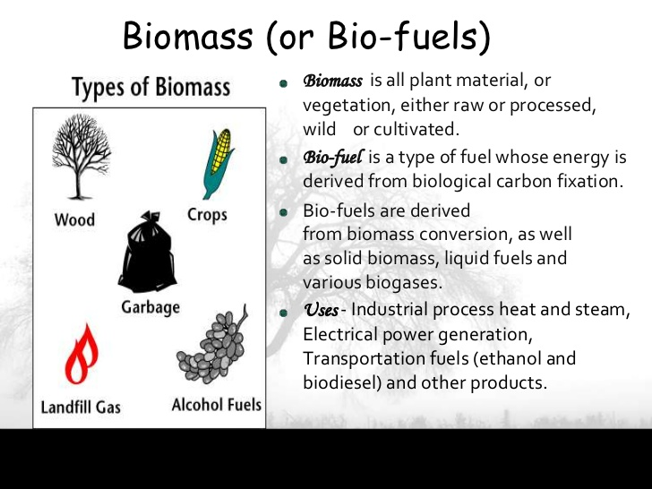

- Wht is agriculture?
Ans: sry didn’t get this!!!
- Sustainable agriculture?
Ans:
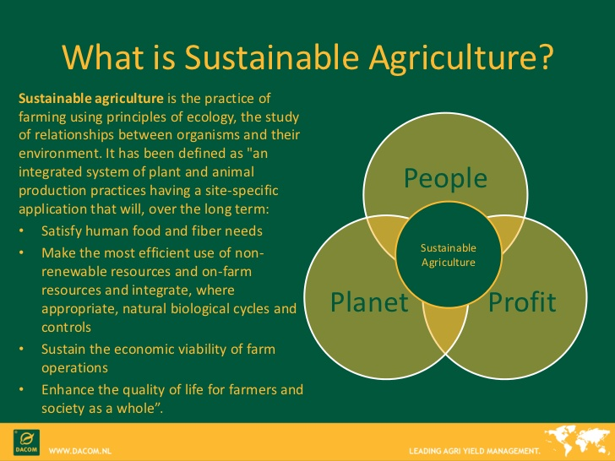
- Sustainable Agricultural-Method of growing crops and raising livestock based on organic fertilizers, soil conservation, water conservation, biological control of pests, and minimal use of nonrenewable fossil fuel energy
- Stalagmites,stalagtites?
Ans: Stalagmite: A mound or tapering column rising from the floor of a cave, formed of calcium salts deposited by dripping water and often uniting with a stalactite
A stalactite is an icicle-shaped formation that hangs from the ceiling of a cave, and is produced by precipitation of minerals from water dripping through the cave ceiling. Most stalactites have pointed tips.

- Rock types?
Ans: Geologists classify rocks in three groups, according to the major Earth processes that formed them. These are
(i) Igneous,
(ii) Sedimentary, and
(iii) Metamorphic rocks
- Metamorphic rocks?
Ans: Metamorphic rocks arise from the transformation of existing rock types, in a process called metamorphism, which means "change in form".
The original rock (protolith) is subjected to heat (temperatures greater than 150 to 200 °C) and pressure (1500 bars), causing profound physical and/or chemical change. The protolith may be a sedimentary rock, an igneous rock or another older metamorphic rock.
Metamorphic rocks make up a large part of the Earth’s crust and are classified by texture and by chemical and mineral assemblage (metamorphic facies).
- Wht is regolith?
Ans: Regolith is a layer of loose, heterogeneous superficial material covering solid rock. It includes dust, soil, broken rock, and other related materials and is present on Earth, the Moon, Mars, some asteroids, and other terrestrial planets and moons

